**What Is Semantic HTML?**

HTML tags that convey the meaning—or semantics—of the content contained within them.

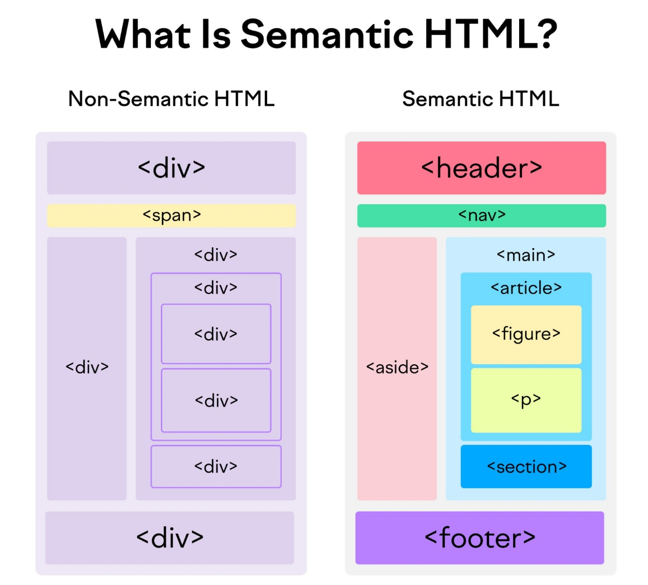

USES :

Accessibility- for **blind or visually impaired** and rely on screen readers.

[SEO](https://www.semrush.com/blog/what-is-seo/) (search engine optimization)

## Types of HTML Semantic Tags

* [HTML semantic tags for structure](https://www.semrush.com/blog/semantic-html5-guide/#html-semantic-tags-for-structure)
* [HTML semantic tags for text](https://www.semrush.com/blog/semantic-html5-guide/#html-semantic-tags-for-text)
* **<header>**: The header tag defines content that should be considered the introductory information of a page or section
* **<nav>**:
  + The navigation tag is used for navigation links. It can be nested within the <header> tag, but secondary navigation <nav> tags are also commonly used elsewhere on the page.
* **<main>**:
  + This tag contains the main content (also called the body) of a page. There should be only one tag per page.
* **<article>**:
  + The article tag defines content that could stand independently of the page or site it’s on. It does not necessarily mean a “blog post.” Think of it more as “an article of clothing”—a self-contained item that can be used in various contexts.
* **<section>**:
  + Using <section> is a way of grouping nearby content of a similar theme. A section tag differs from an article tag. It isn’t necessarily self-contained, but it forms part of something else.
* **<aside>**:
  + An aside element defines content that’s less important. It’s often used for sidebars—areas that add complementary but nonessential information.
* **<footer>**:
  + You use <footer> at the bottom of a page. It usually includes contact information, copyright information, and some site navigation.